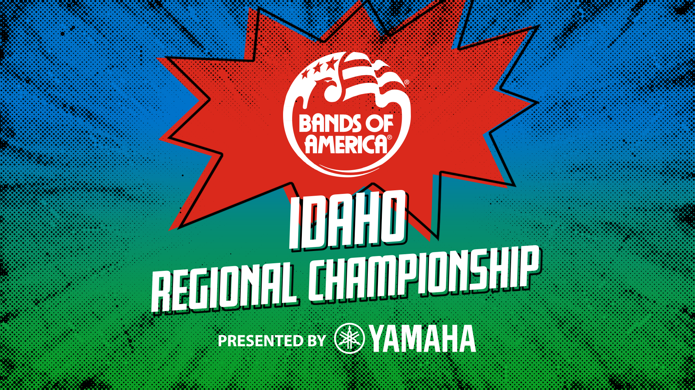

2024 Bands of America Championship Season Continues in Moscow, Idaho Oct. 12
9 high school marching bands will compete for the regional championship title

MOSCOW, IDAHO- High School marching band students from across the region will perform at the Bands of America Idaho Regional Championship presented by Yamaha, Saturday, Oct. 12 at P1FCU Kibbie Dome Stadium at the University of Idaho.

Bands from Idaho, Oregon, and Washington will compete. Bands of America Championships are the nation’s premier marching band events, showcasing outstanding student musicians and visual performances.

For a look at the full schedule of bands, visit musicforall.org.

This event is hosted by the University of Idaho Vandal Marching Band.

"Marching band is even more than music and performance; it's a powerful experience that builds discipline, teamwork, and lifelong memories,” says Dr. Jeremy Earnhart, President and CEO of Music for All, the parent organization for Bands of America. “Participating in Bands of America Championships takes that to the next level, challenging high school students to strive for excellence, showcase their talents on a national stage, and feel the pride of being part of something truly extraordinary.”

Bands take the field for preliminary competition performances at 12:30 p.m. Doors will open to the public at 12:00 p.m. The University of Idaho Vandal Marching Band will perform in exhibition at 2:45 p.m. Times are subject to change, visit marching.musicforall.org for the latest event schedule.

Performances will be evaluated by a panel of nationally recognized music educators and marching band experts. The 12 highest-scoring bands will advance to the evening finals with the top-scoring band named champion at the end of the night. The first competing finalist band is at 7:15 p.m. with gates opening at 6:15 p.m.

The Bands of America Championships season includes 30 events across America, culminating with the Bands of America Grand National Championships Nov. 14-16 at Lucas Oil Stadium in Indianapolis.

Tickets

All tickets are digital, and the event is cashless. You can skip the line and buy tickets online at marching.musicforall.org/boa.

Check out the website marching.musicforall.org/boa for all ticket options, including full day passes, tickets for finals and student group tickets, as well as stadium policies to know before you go.

Children 10 years or younger are admitted for free for general admission seating.

###

About Music for All
Music for All’s mission is to create, provide, and expand life-changing experiences through music. Our vision is to be a catalyst to ensure that every child in America has access and opportunity for active music-making in their scholastic environment. A 501(c)(3) nonprofit educational organization, Music for All’s events and programs serve more than 600,000 attendees annually –– and more than 1.7 million program participants since 1975. Programs include the Bands of America Championships for marching bands, a summer music camp for students and teachers, festivals for concert bands and orchestras, national honor ensembles for students, and educational webinars, podcasts, and online resources for teachers.
Music for All’s efforts are supported by national presenting sponsor Yamaha Corporation of America and its family of sponsors, strategic partners, and grantors.

Follow Us!
You can keep up with the latest information for Music for All online at musicforall.org, Facebook (@musicforallnetwork and @bandsofamerica,) Instagram (@officialmusicforall,) and TikTok (@officialmusicforall.)

Sponsor Information
Music for All efforts are supported through sponsorships, including current partnerships with National Presenting Sponsor: Yamaha Corporation of America; Official Instrument Rental Partner: Sweetwater Sound Inc.; Official Uniform Sponsor: Fred J. Miller, Inc.; Official Student Travel Partner: Music Travel Consultants; Official Spirit Wear Sponsor: PepWear; Corporate Sponsors: Ball State University and Visit Indy; and Associate Sponsor: StylePlus. Music for All is also supported by the Arts Council of Indianapolis and the City of Indianapolis; Ball Brothers Foundation; Lilly Endowment Inc.; George and Frances Ball Foundation; Allen Whitehill Clowes Charitable Foundation, Inc., Nicholas H. Noyes, Jr., Memorial Foundation, Inc, and the Arthur Jordan Foundation.

Media Contact:
Rachel Puckett, Promotions Senior Coordinator
Music for All
rachel.p@musicforall.org
Direct Phone: 317.218.4894

