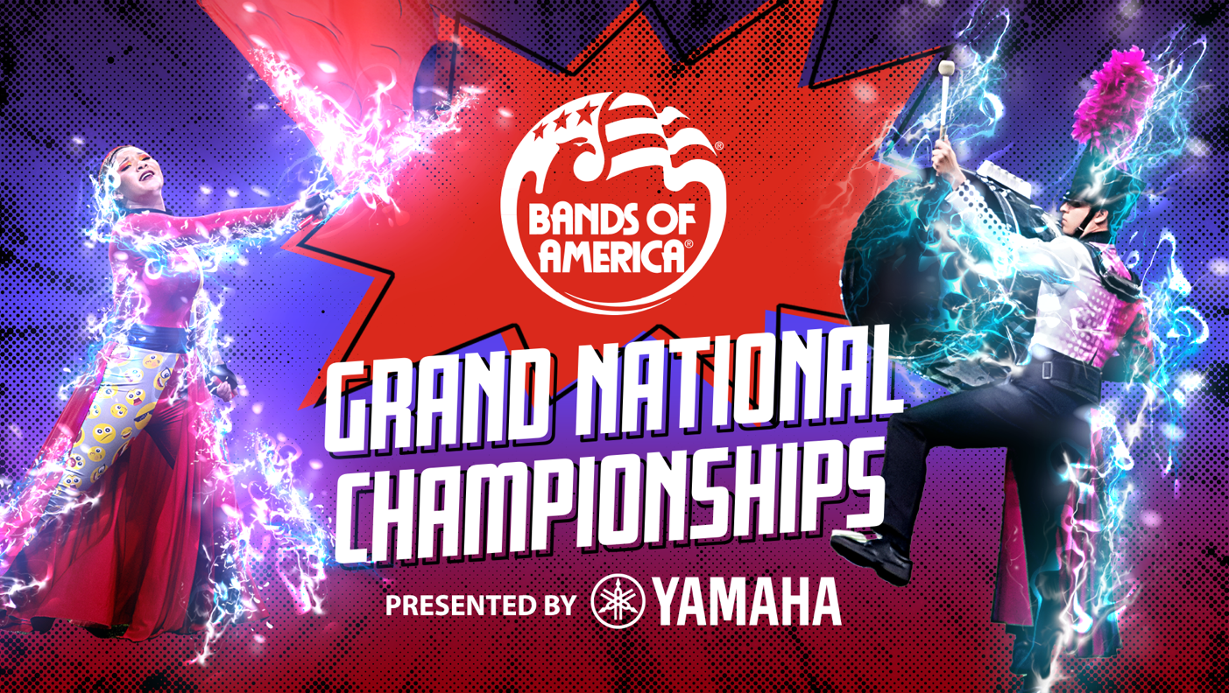

2024 Bands of America Grand National Championships concludes season this weekend with record-breaking participation
113 high school marching bands will compete for the Grand National Championship title Nov. 14-16 in Indianapolis

INDIANAPOLIS, INDIANA – Nearly 16,500 high school marching band students from 20 states will perform at the Bands of America Grand National Championship, presented by Yamaha, on Nov. 14-16 at Lucas Oil Stadium this weekend.

A record-high 113 bands are scheduled to compete from Alabama, Florida, Georgia, Illinois, Indiana, Kentucky, Michigan, Minnesota, Missouri, Mississippi, North Carolina, Ohio, Oklahoma, Pennsylvania, South Carolina, Tennessee, Texas, Utah, Washington, and Wyoming. Bands of America Championships are the nation’s premier marching band events, showcasing outstanding student musicians and visual performances.

The competition will be spread over three days, Thursday through Saturday. The preliminary competition will start Thursday morning at 7:00 a.m. and conclude on Friday with a special exhibition performance by Missouri State University Pride Marching Band at 8:45 p.m.

"Marching band is even more than music and performance; it's a powerful experience that builds discipline, teamwork, and lifelong memories,” says Dr. Jeremy Earnhart, President and CEO of Music for All, the parent organization for Bands of America. “The Grand National Championships is the pinnacle of performance opportunities for high school marching bands. Participation takes the benefits of participating in music to the next level, challenging high school students to strive for excellence, showcase their talents on a national stage, and feel the pride of being part of something truly extraordinary.

The benefits developed by participation in school music are the soft skills that employers point to as skills required for their workforce.”

Grand National performances will be evaluated by a panel of nationally recognized music educators and marching band experts. Thirty bands will advance to the semi-finals on Saturday. The doors will open at 6:30 a.m. and the semi-finals competition will begin at 7:00 a.m. (actual start time to be determined after the conclusion of Friday night’s prelims awards ceremony).

Saturday also features exhibition performances by The Ohio State University Marching Band and the University of Michigan Marching Band at 4:30 p.m. Then the two schools will transcend rivalry and perform together along with student musicians from United Sound, a nonprofit organization whose mission is to remove barriers and foster social change through music.

The 12 highest-scoring bands will advance to Saturday evening’s finals, starting at 7:00 p.m., with the top-scoring band named Grand National Champion at the end of the night.

For a look at the full schedule of bands, visit marching.musicforall.org/gn.

The Bands of America Championships season included 30 events across America, culminating with the Bands of America Grand National Championships.

Tickets

All tickets are digital and through Ticketmaster, and the event is cashless. You can skip the ticket line and buy tickets online at marching.musicforall.org/boa. Tickets are available on site at the Lucas Oil Stadium ticket office.

Check out the website marching.musicforall.org/gn for all ticket options, including tickets for prelims, semi-finals, finals reserved seats, and student group tickets, as well as stadium policies to know before you go.
###

About Music for All
Music for All’s mission is to create, provide, and expand life-changing experiences through music. Our vision is to be a catalyst to ensure that every child in America has access and opportunity for active music-making in their scholastic environment. A 501(c)(3) nonprofit educational organization, Music for All’s events and programs serve more than 600,000 attendees annually –– and more than 1.7 million program participants since 1975. Programs include the Bands of America Championships for marching bands, a summer music camp for students and teachers, festivals for concert bands and orchestras, national honor ensembles for students, and educational webinars, podcasts, and online resources for teachers.
Music for All’s efforts are supported by national presenting sponsor Yamaha Corporation of America and its family of sponsors, strategic partners, and grantors.

Follow Us!
You can keep up with the latest information for Music for All online at musicforall.org, Facebook (@musicforallnetwork and @bandsofamerica,) Instagram (@officialmusicforall,) and TikTok (@officialmusicforall.)

Sponsor Information
Music for All efforts are supported through sponsorships, including current partnerships with National Presenting Sponsor: Yamaha Corporation of America; Official Instrument Rental Partner: Sweetwater Sound Inc.; Official Uniform Sponsor: Fred J. Miller, Inc.; Official Student Travel Partner: Music Travel Consultants; Official Spirit Wear Sponsor: PepWear; Corporate Sponsors: Ball State University and Visit Indy; and Associate Sponsor: StylePlus. Music for All is also supported by the Arts Council of Indianapolis and the City of Indianapolis; Ball Brothers Foundation; Lilly Endowment Inc.; George and Frances Ball Foundation; Allen Whitehill Clowes Charitable Foundation, Inc., Nicholas H. Noyes, Jr., Memorial Foundation, Inc, and the Arthur Jordan Foundation.

Media Contact:
Rachel Puckett, Promotions Senior Coordinator
Music for All
rachel.p@musicforall.org
Direct Phone: 317.218.4894

